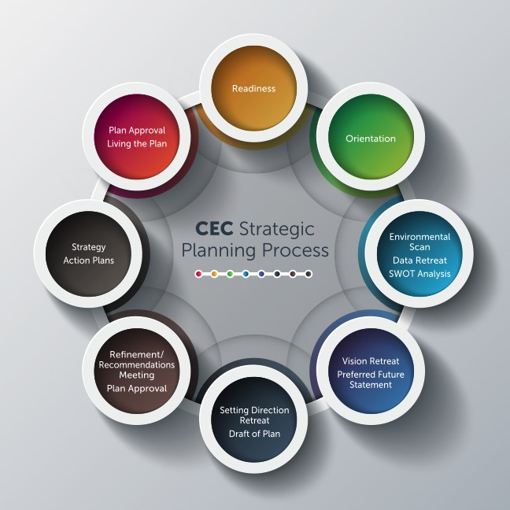

Steps in the Process | Description
Readiness | The purpose of the Readiness/Introduction Session is to acquaint the district with the strategic planning process. It is essential in alignment with CEC’s mission that the process be a joint endeavor between labor and management and include leaders of the board, union and management. Leaders representative of those groups must attend the introduction session. This session will be facilitated by CEC. Following this session, CEC will finalize a contract and submit it to the district to establish final expectations, roles, responsibilities, costs and timelines.
Orientation | The purpose of the Orientation is to answer the question, “WHO ARE WE AND WHAT ARE WE BEING ASKED TO DO?” The Orientation session paints the “The Big Picture” of the strategic planning process so that all strategic planning team members have a shared understanding of the process and their roles and responsibilities in helping the district set clear direction for the future.
Environmental Scan; Data Retreat; SWOT Analysis | The purpose of the Data Retreat is to answer the question, “WHERE ARE WE NOW?” During this day the strategic planning team will develop a shared understanding of the current situation of the district as identified through data. The outcome of the day is to paint a clear data picture of the district so that the strategic planning team can identify what is working well (STRENGTHS), what is not working well (WEAKNESSES), what are possible areas of need (OPPORTUNITIES), and what are potential impacts (THREATS). This is called a SWOT analysis. This is a recommended six-hour session.
Vision Retreat; Preferred Future Statement | The purpose of the Visioning Retreat is to answer the question, “WHERE DO WE WANT TO BE?” During this day the strategic planning team will develop a shared understanding of the current mission, vision, values/beliefs/commitments and goals of the district. The team will review the components of a continuous improvement framework. It addition, it will look at essential information to shape a future vision based on the SWOT analysis from the data retreat. This provides the team with an opportunity to look at best practice research that guides improvement. The outcome of the day is to paint a clear vision of where the district hopes to be in the future. This is a recommended six-hour session.
Setting Direction Retreat; Draft of Plan | The purpose of the Setting Direction Retreat is to answer the question, “HOW DO WE GET FROM WHERE WE ARE TO WHERE WE WANT TO BE?” The strategic planning team works to provide a draft of the strategic vision/plan that can be shared with stakeholders to provide opportunities for input and feedback. The team will address long-range goals, preview goal indicators and measures and identify the most urgent strategies that need to be addressed during the plan’s duration to move the district to a higher level of performance. This is a recommended six-hour session.
Refinement/ Recommendations Meeting | The purpose of the Final Meeting of the strategic plan team is to review feedback from stakeholders on the draft of the new plan and make any refinements to the plan before it is presented to the superintendent who will recommend plan approval to the board of education. This is a recommended three-hour session.
Strategy Action Plans | It is recommended that the district use a Plan-Do-Study-Act process to develop strategy action plans. Leaders of the action teams should be trained to ensure the PDSA process is used consistently. Be certain action plans are SMART. Align key action plans with district department leaders and shared decision-making committees. Be certain those impacted by the action plans have opportunities to provide into input to their design and development. Be certain the action plans identify tasks that are research-based and ensure action will be different from what has been done. Doing the same things produce the same results. Recognize the importance of “study” and “act” of the PDSA process.
Plan Approval; Living the Plan | There are several critical strategies to be certain the plan does not sit on the shelf and collect dust: Critical strategies that CEC offers to ensure the return on the investment include:  - Align goals and strategies to a data system (Indicators, Measures, and Targets).  - Align the data system to a progress monitoring and reporting system for all stakeholders.  - Align the plan to the work structures and processes to ensure ownership, responsibility and accountability.  - Align the plan to individual and team performance and program evaluation (goal setting, feedback, reflection, and improvement).  - Align the plan strategies to PDSA action plans to develop a two-way communication and collaboration system to listen and learn.  - Align the plan to resources of time and money to ensure focus and priority.

